EC Techincal Document for the Following:
Product: 3D Printer
Model: LulzBot Mini v1.0
Serial number: KT-PR0035-****

Manufacturer:
Aleph Objects, Inc.
626 Westh 66th Street
Loveland, Colorado 80538 USA
+1-970-377-1111

The 3D printer takes a digital file and creates a 3D model out of plastic. It is an additive process that creates parts by laying down successive layers of material until the entire object is created. The system is made up of a processor board, power supply, heated nozzle, plastic extruder, heat bed and motor drives to contol the 3 axis of movement.

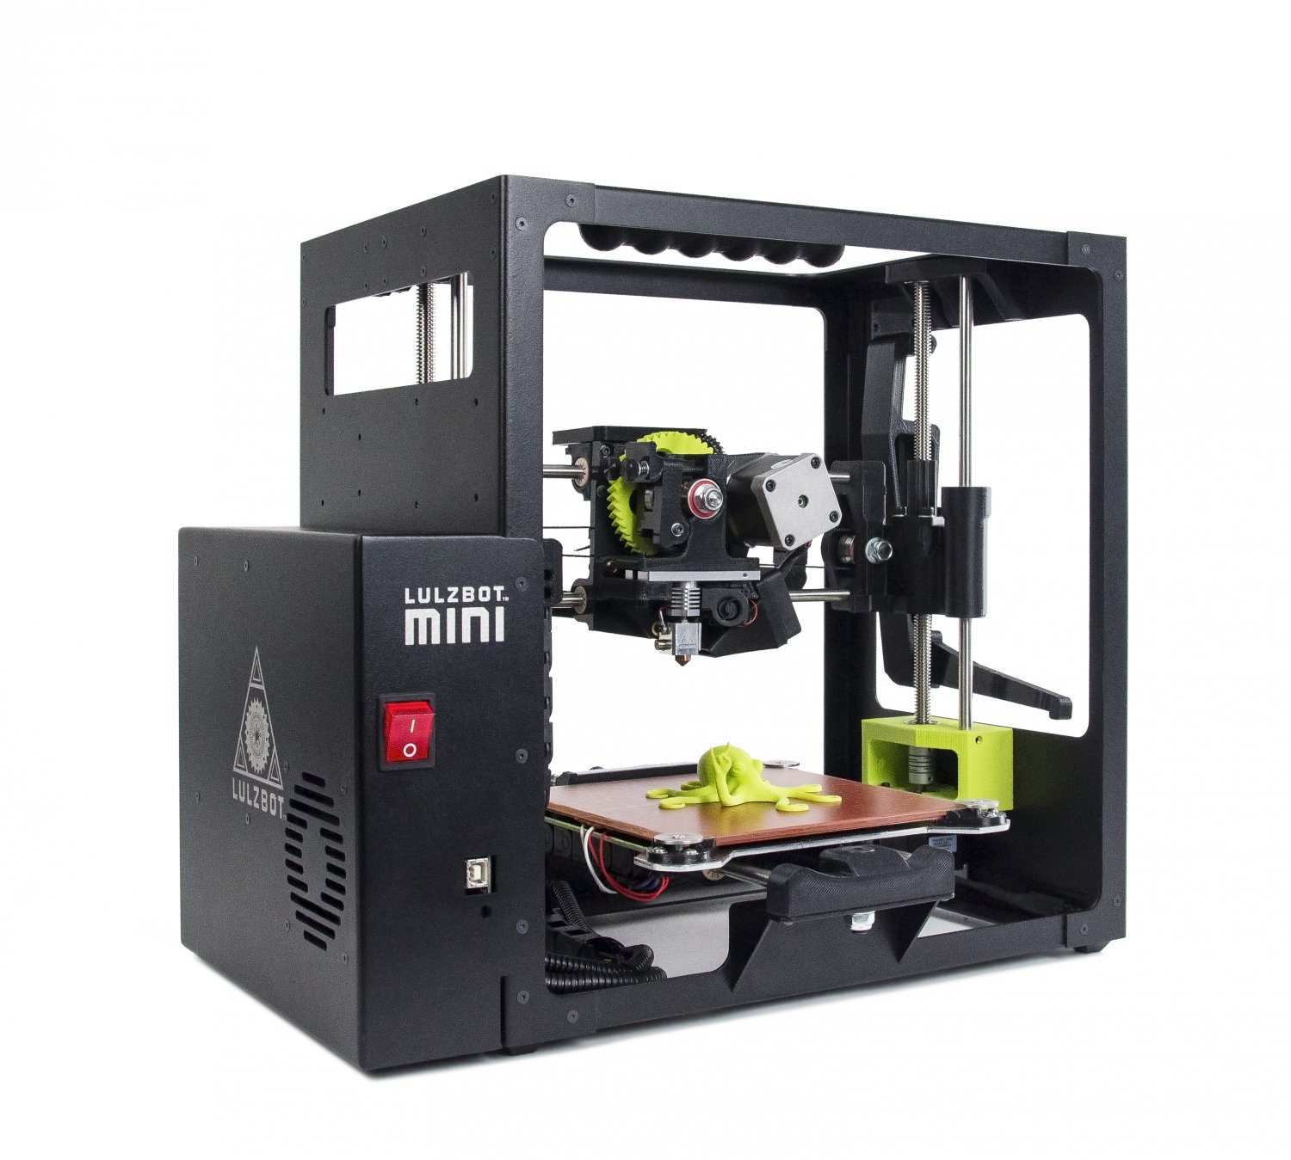Illustration 1: LulzBot Mini v1.0 3D Printer

The techincal files for the LulzBot Mini can be found at download.lulzbot.com/Mini/1.0/. There you will find manufacturing drawings, design concepts, wiring schematics and assembly instructions. As an open sourse company, all of these files are avalible at any time to anyone.

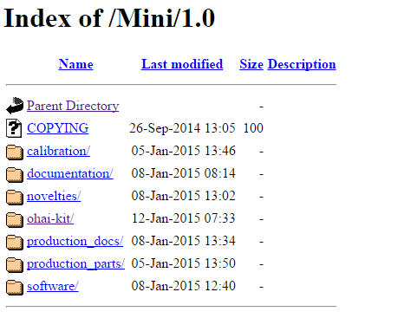Illustration 2: Index of Downloads

In the “documentation” directory you will find the files for the manual, quick start guide and the safety warnings document for the LulzBot Mini v1.0 3D Printer.
The “ohai-kit” directory includes a snapshot of the assembly sequences for the LulzBot Mini v1.0 3D Printer. It's broken into sub assemblies for each work step. The electrical cover assembly and eletrical final assembly is where you can see how the wiring is assembled in the LulzBot Mini v1.0 3D Printer.
The “production_docs” directory includes files like the Bill of Materials (BOM), the CE DoC, test reports on CE testing, and other paperwork we provide with the LulzBot Mini v1.0 3D Printer.
The “production_parts” directory includes part drawings, stl files for making the printers, native file format files for users to download, and manufacturing drawings for the wire harnesses.

In order to declare the LulzBot Mini v1.0 3D Printer is in copliance with the essential requirements of the Low Voltage Directive (2014/35/EU), Electromagnetic Compatiblity Directive (2014/30/EU) and Restrition of the use of certain hazardous substances (2011/65/EU) we have used the standards listed below. The full test reports for EMC testing can be found at download.lulzbot.com/Mini/1.0/production_docs/CE_docs. All of the standars listed below we passed by the LulzBot Mini v1.0 3D Printer.

Standards: EN 61000-6-3:2011
AS/NZ CISPR22:2010
FCC 47CFR Part 15 Subpart B: 2015
ICES-003: 2012
EN 55022:2010
EN 55024:2010

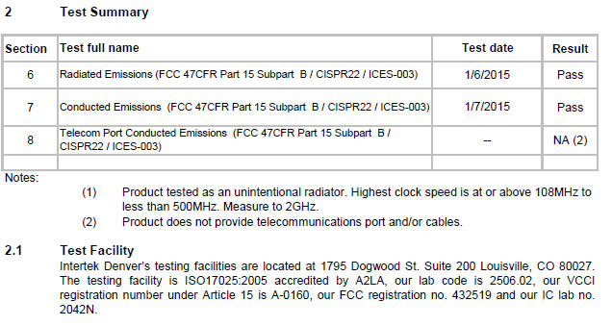Illustration 3: Intertek test Summary
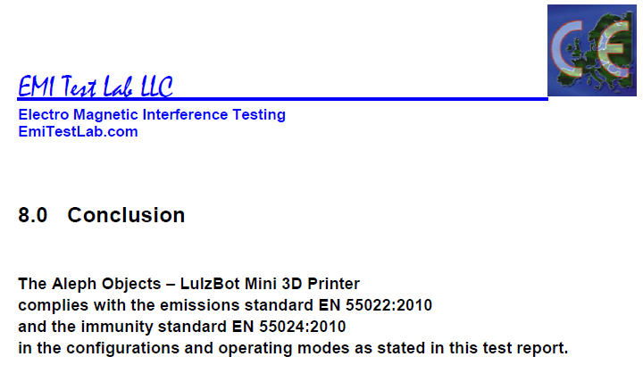Illustration 4: EMI Test Lab, LLC Summary

To adhere to the Restrition of the use of certain hazardous substances directive we have chosen to only sourse materiasl that are RoHS compliant. Our Bill of Materials (BOM) lists all products and materials that are used in the construction of the LulzBot Mini v1.0 3D Printer as well as vendor and vendor part numbers for each part.

