FAILURE ANALYSIS REPORT

NAME: Brent MacKenzie | DATE: 11/1/2014
ITEM DESCRIPTION:  Hexagon hotends – Lulzbot edition | SERIAL NO:  multiple
FAILURE REPORT DATE: 11/1/2014 | ORIGIN: Internal - R&D

FAILURE MODE/ DESCRIPTION:  Bed leveling on on 2 Mini printers appeared to get worse (more squished) over time. Inspection revealed that the small M2 set screw in the bottom of the heatsink had backed out over time, and the heater block was able to slide up and down in the heater block.  In a 3rd unrelated failure, the welds holding the set screw ring into the heatsink failed completely, allowing the hotend to slide in and out of the tube. | SYMPTOMS:  - Over-squishing of the first layer in prints  - Perceptible movement of the inner tube relative to the heatsink  - Loose / fallen out set screws

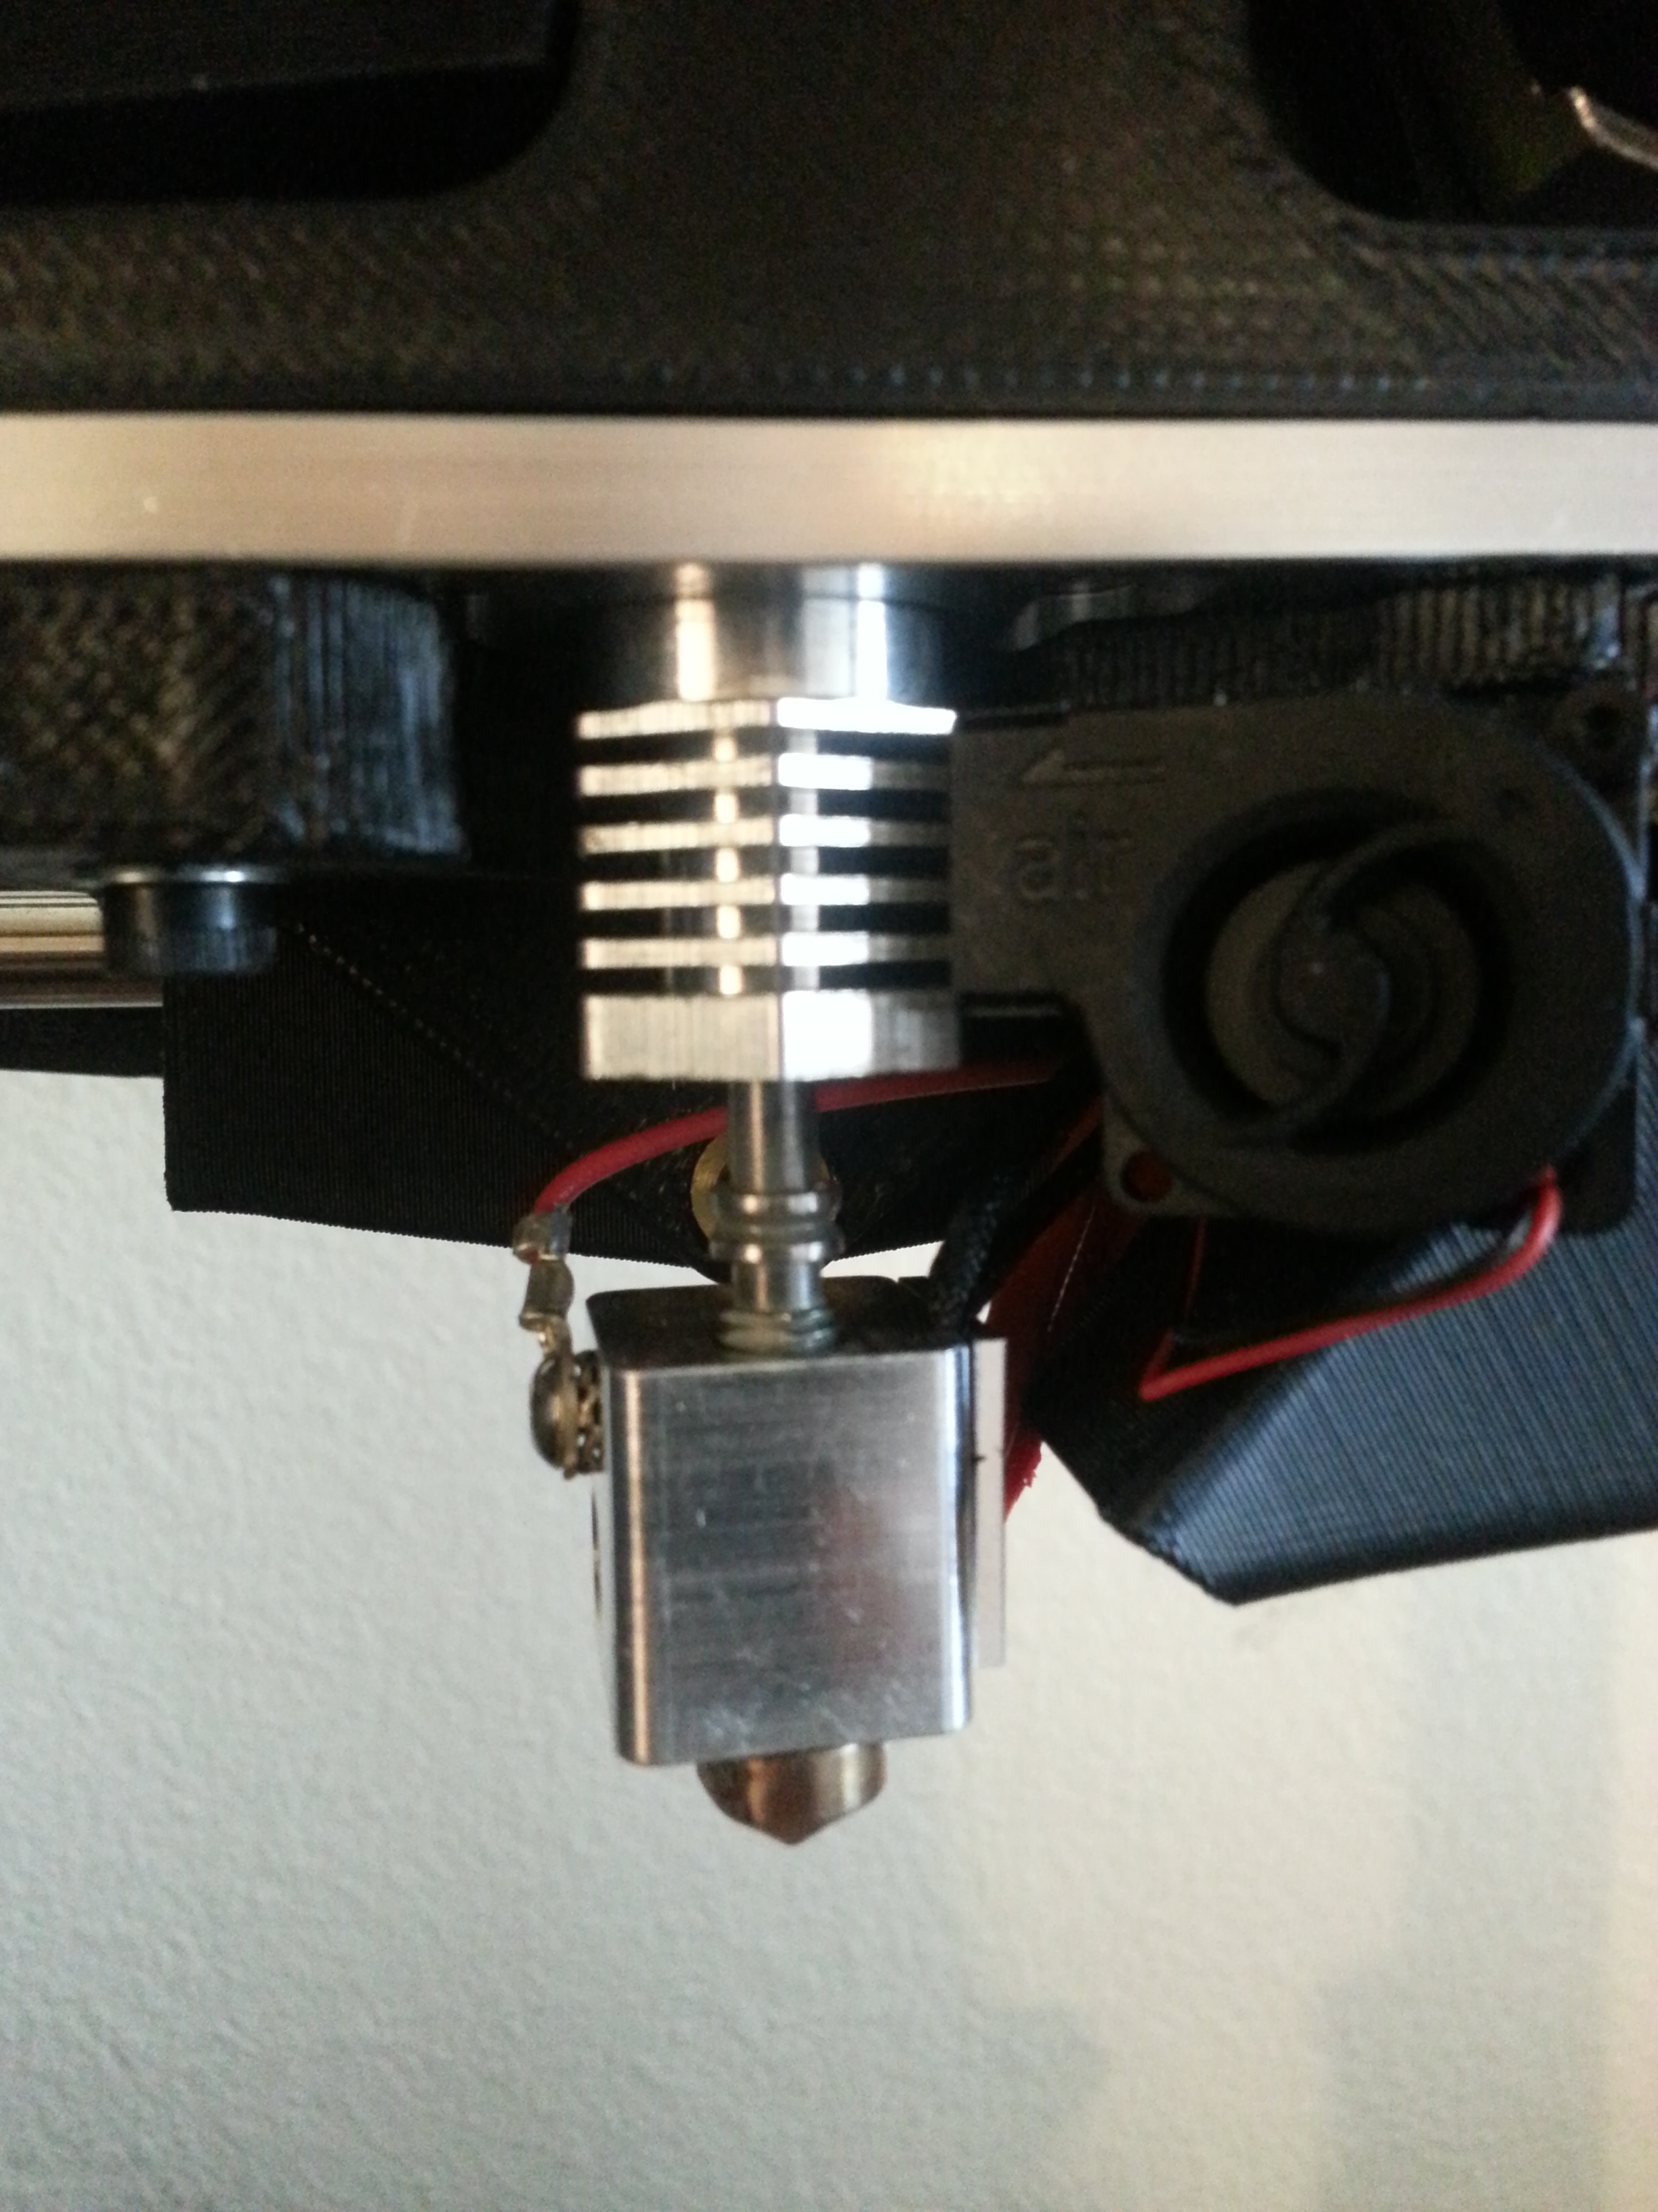
OBSERVATIONS & FINDINGS & PICTURES

Set screw issue:

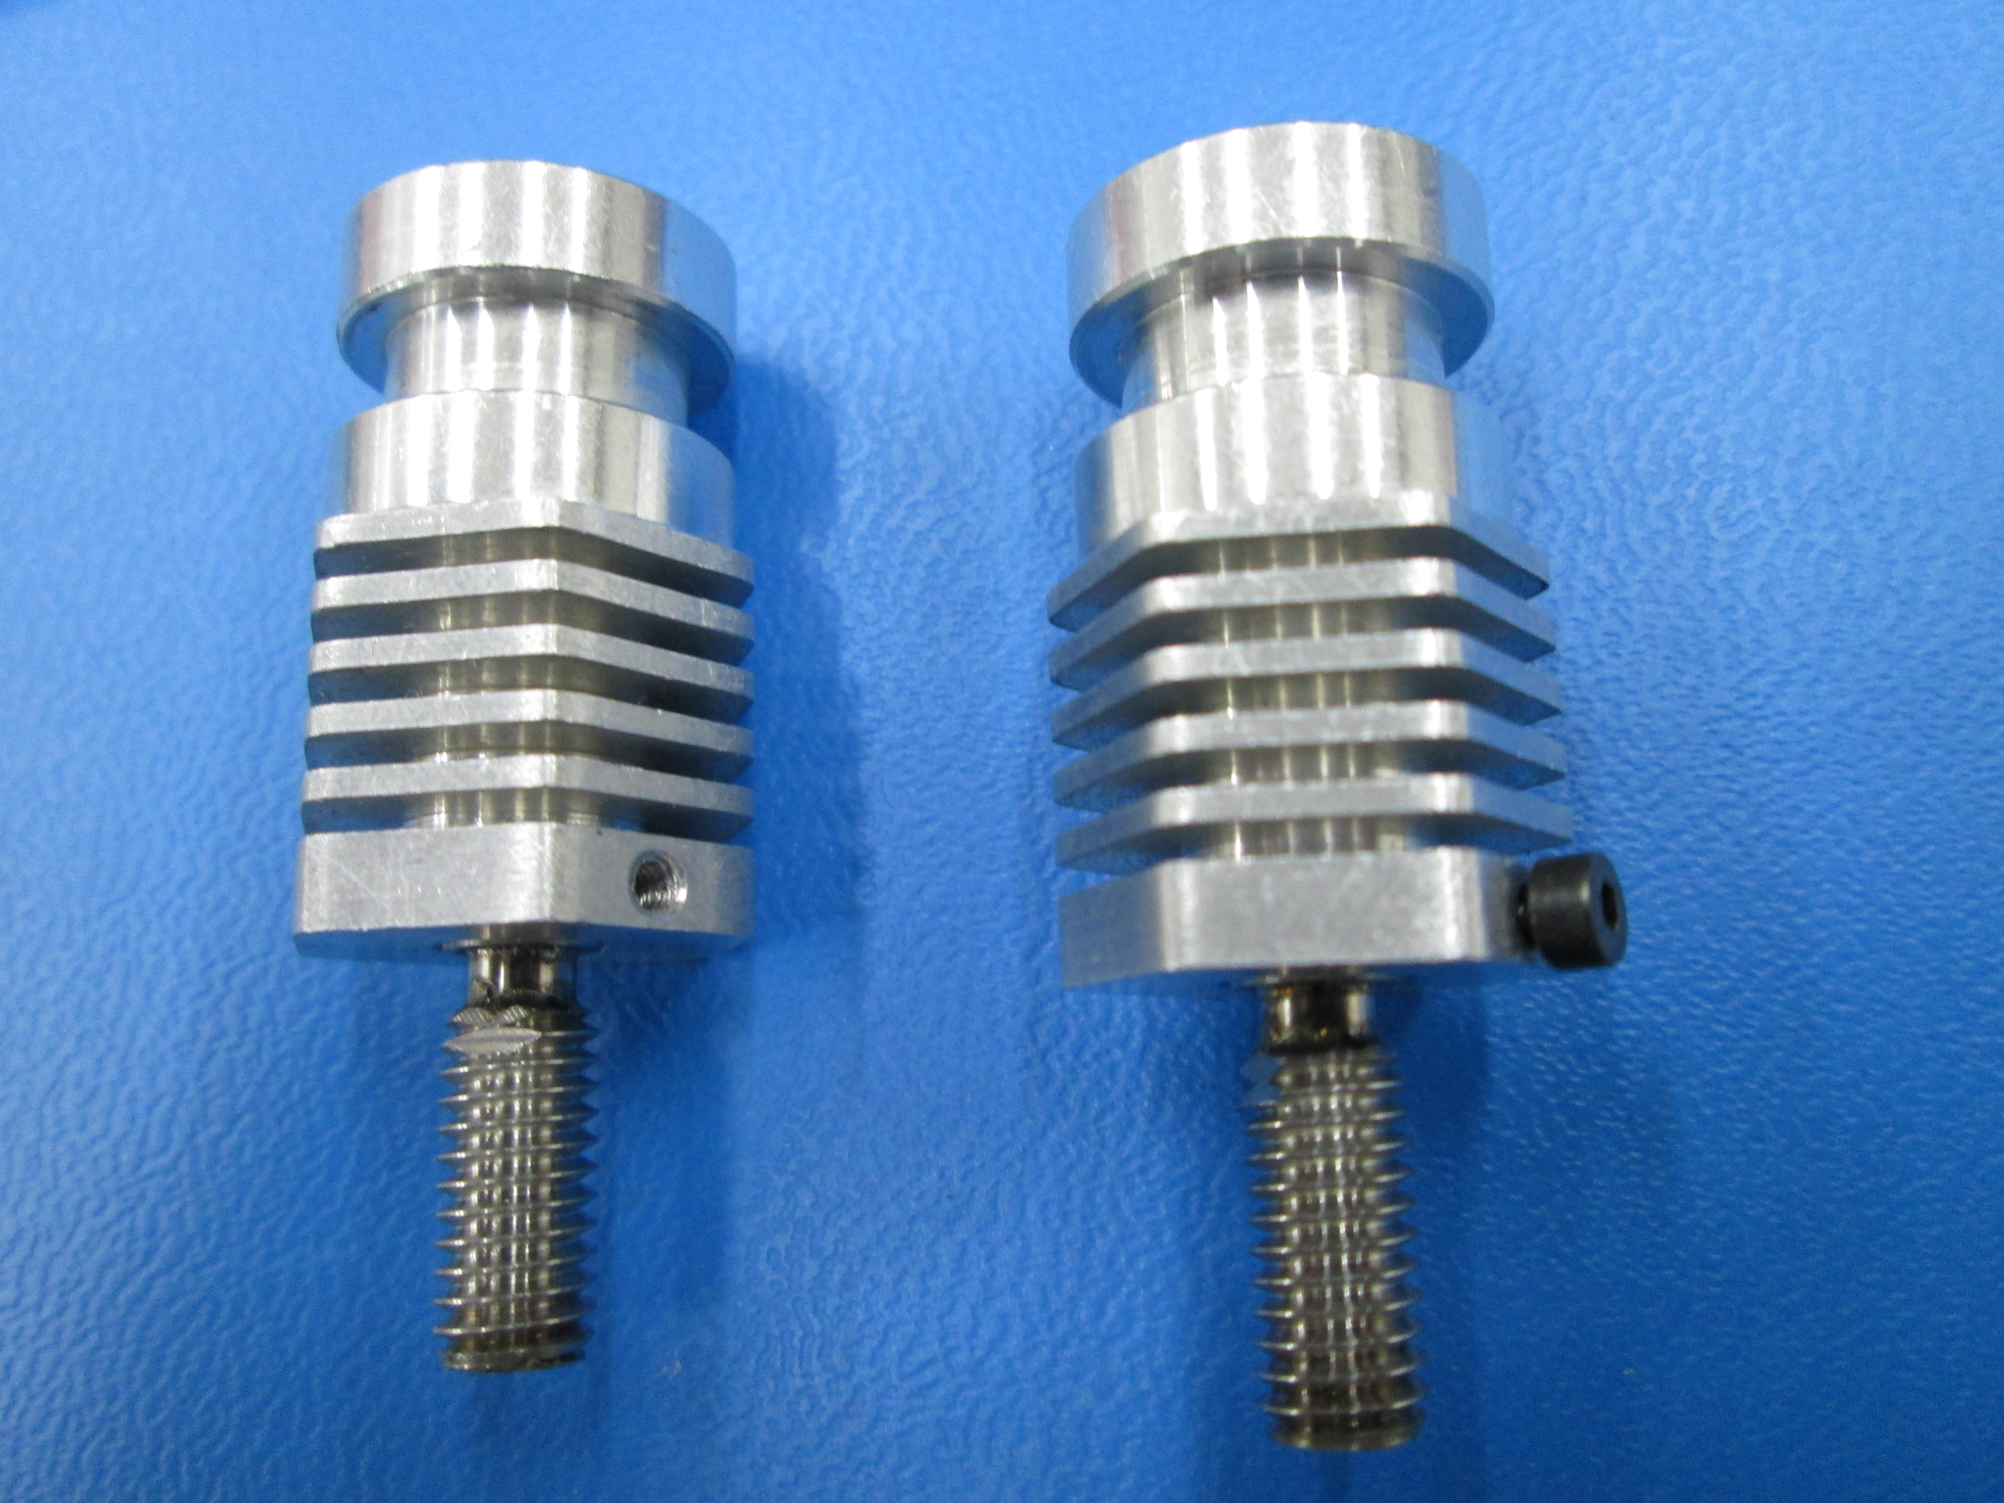

Set screw fix:

Weld break:
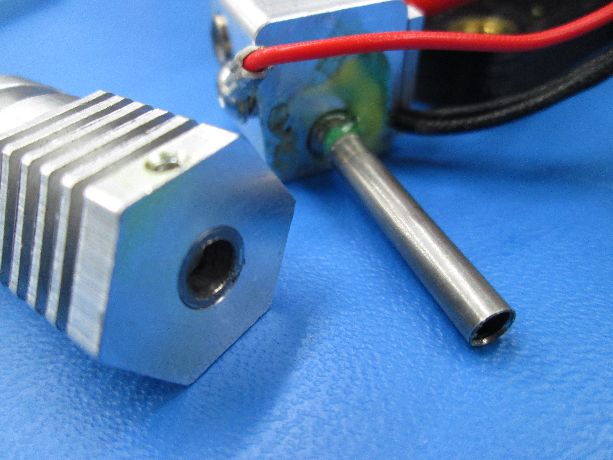

CONCLUSION/ ROOT CAUSE: We believe that most of the failures are a result of improperly tightened set screws that are allowed to back out over time. The impact from the wiping / probing sequences might have contributed to the failure as well. I suggest replacing the M2 set screw with a M2x6mm socket cap screw in order to be able to tighten them more reliably in assembly, and with the same 1.5mm tool that is used for the heater block set screw. If failures are still observed then a design change may be necessary.

CORRECTIVE ACTIONS/ FIXES | OWNER | COMPLETION DATE
Get all camellias set up with M2x6 SCHS in place of the M2x3 set screws. | Brent M | 11/2/2014
Get in touch with RRD about the loosening set screws & see if there are any other fixes we should try | Brent M | 11/1/2014
Find out what the failure rate is for standard hexagon welds to determine if we need a design change for batch 2 of the ao-hexagon nozzles | Brent M | 11/1/2014

