LulzBot Filament Testing Report

Manufacturer: Push Plastics
Filament Type: HIPS
Tested By: Angelica Nolen
Date: 10/27/2017

Ease of use: 6/10
Appearance: 8/10
Color consistency: 9/10
Print temperature Range (C): 225-2
Variance in diameter: (2.75-2.88)
Minimum bend radius: 11mm minimum bend radius
Prints using current Lulzbot profiles/temps:
Tested using ABS – Chroma Strand Labs – (225-245°C )

General Notes: (Be as detailed as possible)
- Packaging: Sealed plastic, no issues
- Melting point, per manufacturer: 90-135°C
- Flash point, per manufacturer: >280°C
- Decomposition, per manufacturer >300°C – Do not print at or above this temperature
- Easily Removed from bed, good bed adhesion when using PEI
- Always check nozzle Tensions, Hob teeth can shred filament easily (AeroStruder)
- Leaving filament hot in the nozzle for long periods results in yellow burnt extrusion until flushed
- Cools rapidly without assistance
- Testing Info: Taz 6 singlestruder, Mini Singlestruder, Mini Aerostruder, all with PEI sheet
- Bubbles found in filament of first batch, (**UPDATE: new batch is clear of bubbles)
- Easily snapped under any rapid pressure
- the filament shows a slight cloudy white at first and if any stress is applied it then goes to a complete opaque white, this stress does not seem to effect the print quality, color, or consistency.
- INCOMPATIBLE MATERIALS: (10.5 in MSDS) Strong oxidizing agents, gasoline, aldehydes, ketone
- Printing Temperature Range: 225-270°C
- Bed temperature Range: 105-115°C
- DO NOT INGEST
- lower fan speeds and higher minimum layer times recommended for cooling of this material
- D-limonene Test – Benchy 100% and Crate with Hips support used – resulted in full dissolve of the benchy and all support material in a little under 20 hours with no agitation to the container.

Recommended Print Profiles: (ie. should we include high clarity, high strength, etc.)
high detail, high speed, and standard recommended

Health or environmental risks:

DO NOT INGEST
Environmental Precautions: Gather Pellets and powder thoroughly to avoid birds or fish taking from draining water. Do not allow product to reach sewage system or water bodies. Inform respective authorities in case product reaches water, sewage system or soil.
(alos notated in 8.3 and 12.2)
(16.4) H411 Toxic to aquatic life with long lasting effects, R51/53 May cause long term adverse effects in the aquatic environment.

Disposal Options:

Dispose in accordance with current local regulations.

Recommendation: (As thorough as possible)
- Recommended

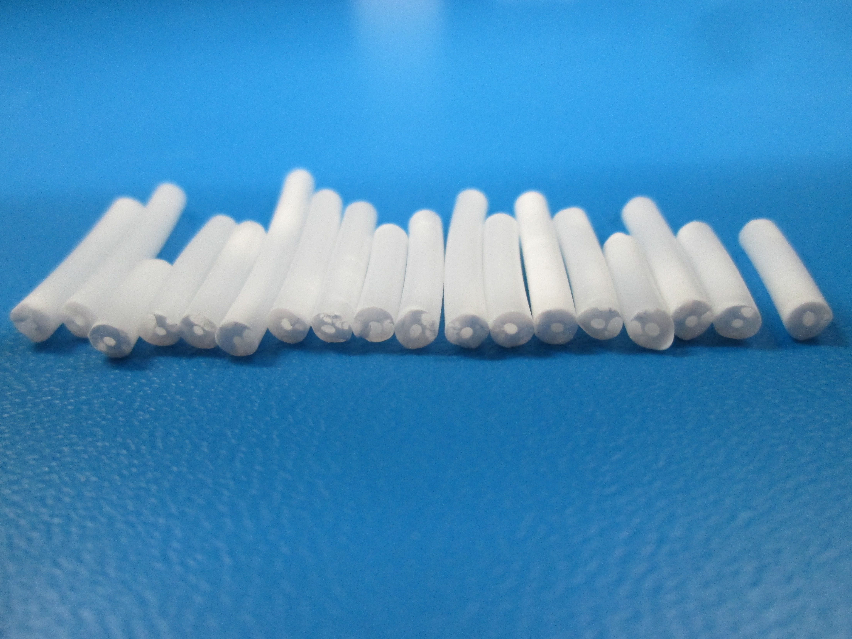

**UPDATE: New hips batch sent, no bubbles found in this new batch.

Revision History

Revision Date | Modifications or Additions | Updated By
06.28.17 | Document Created | J. Pettit
10.30.17 | New Data Recorded | Anolen
03.02.2018 | Confirm material consistency over time | A. Suiter

