LulzBot Filament Testing Report

Manufacturer: 3DFuel
Filament Name: Advanced PLA
Filament Type: PLA
Tested By:
Date: 03/01/2016

Ease of use: X/10
Appearance: X/10
Color consistency: 10/10
Print temperature Range (C): 190-230/50-60
Melting Range: 150-180°C/302-356°F
Conditions to Avoid: Temperatures above 230°C/446°F. Avoid keeping resin molten for excessive periods of time at elevated temperatures. Prolonged exposure will cause polymer degradation.
Variance in diameter: (1.68-1.73mm)
Minimum bend radius: <1”, not especially brittle
Prints using current Lulzbot profiles/temps: Custom profiles should be created. Tested with std PLA with extrusion temp set to 210

Notes:
- This is the same base material and ProtoPasta's high temp PLA, CAS No. 9051-89-2
- Prints well with standard PLA settings, 210 at the extruder is better for fast printing.
- Seems to be a bit stiffer than our e-sun PLA, and had excellent layer adhesion.
- Printed parts heated to 135 are much more rigid than comparable ABS parts, super impressive for a PLA
  - It should be noted that the PLA is still definitely above it's glass transition temperature in this testing, and that a printed part would permanently deform at these elevated temperatures, just not as much.
- Nice glossy surface finish at 205C, good layer adhesion.
  - Mechanical properties and layer adhesion are improved at 210C extruder temperature.
- Extruded in the USA
- Color consistency was good and had nice glossy surface finish

Health or environmental risks:

Principle Routes of Exposure:: Eye contact, skin contact, inhalation, ingestion.
Acute Toxicity: No target organ effects noted following ingestion or dermal exposure in animal studies.
Local Effects: Product dust may be irritating to eyes, skin and respiratory system. Resin particles, like other inert materials, are mechanically irritating to eyes. Ingestion may cause gastrointestinal irritation, nausea, vomiting and diarrhea.
Specific Effects: May cause skin irritation and/or dermatitis. Ingestion may cause gastrointestinal irritation, nausea, vomiting and diarrhea. Inhalation of dust may cause shortness of breath, tightness of the chest, a sore throat and cough. Burning produces irritant flames.
Long Term Toxicity: None found
Carcinogenic Effects: None of the components of this product are listed as carcinogens by IARC, NTP, or OSHA.
Ecotoxicity: EC50/72h/algae > 1100 mg/L
Mobility: No data available
Persistence, Degradability: No data available
Bioaccumulation: Does not bioaccumulate.

Disposal Options:

Dispose of in accordance with national, state, and local regulations.

Recommendation: This advanced PLA is modified to have a higher heat tolerance than normal PLA, and even higher than ABS. In our testing it exhibited more ductility and impact resistance than standard PLA, making it more of a competitor with HIPS or ABS than with our other PLAs. At 135C, it's much more rigid than ABS, although it will still deform pretty readily. It prints well with default Lulzbot PLA settings but does better with the hotend temperature turned up to 210C. It is definitely “LulzBot Approved” from our criteria in R&D. It's only available in a limited range of colors, so it likely would not be a replacement for e-Sun PLA, but could be sold as another offering of high temperature PLA.

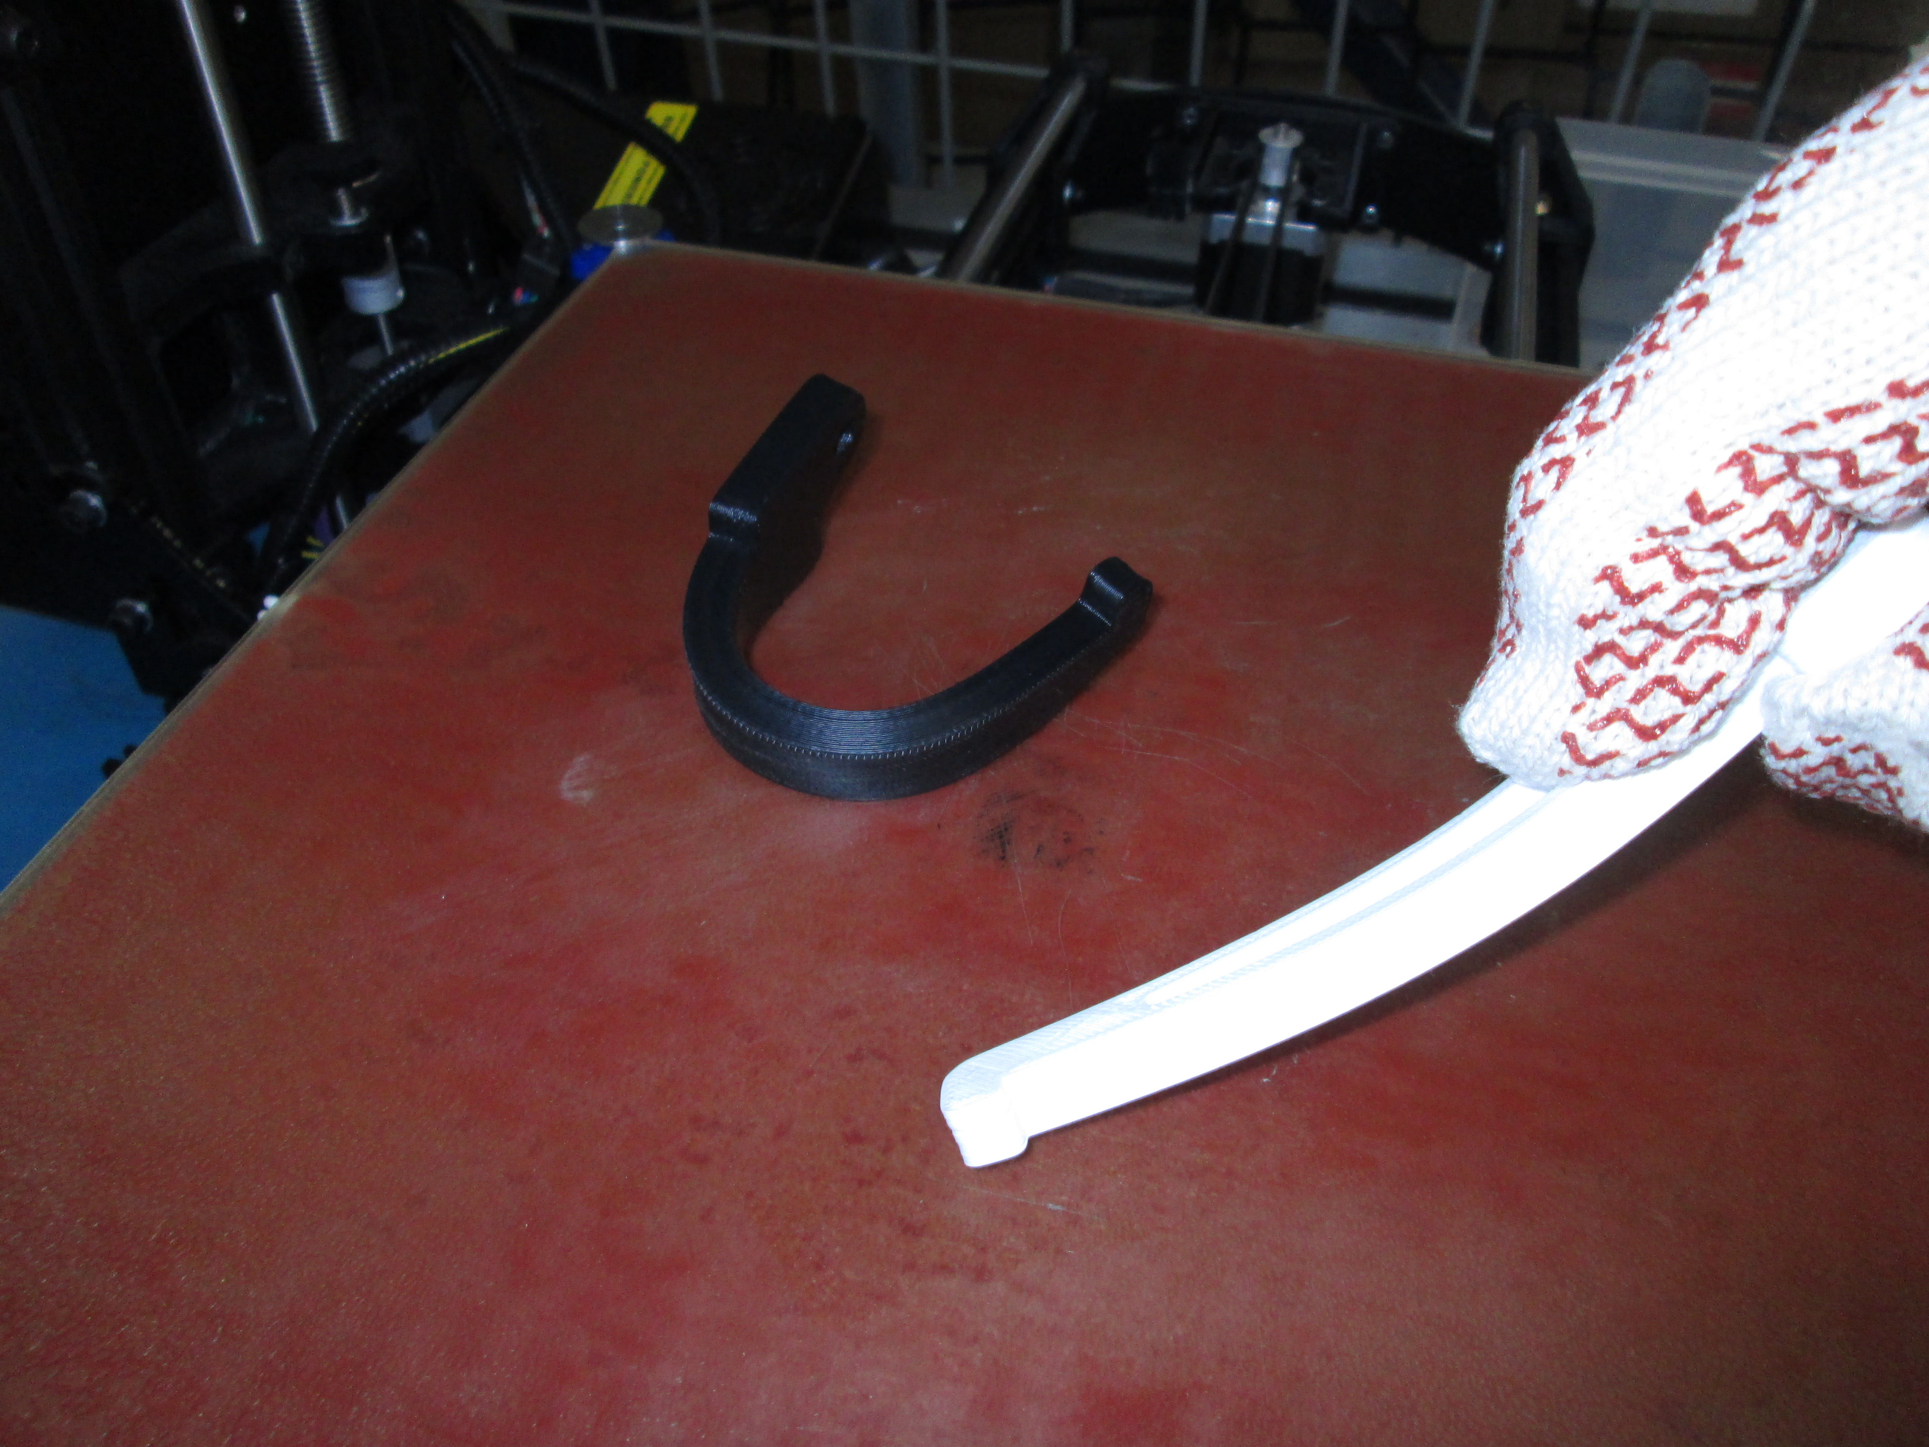
APLA (white) after being removed from a 135C oven exhibits some deformability, but impressively little. For reference the black ABS test piece was very easily bent into a u shape at the same temperature. Pretty cool.

