Title: FCC & Industry Canada
Test Plan: TP-RD-00001
Document Date: 01.18.16
Test Date: 01.15.16
Testing Location: Intertek USA in Louisville, CO

PURPOSE:

Achieve FCC and Industry Canada compliance for AC mains conducted emissions and enclosure radiated emissions.

RESULTS SUMMARY:

During the examination, the Nutmeg 01 passed FCC Class B by a margin of 6.59dBμV/m with 50.72MHz at an azimuth of 253.8° being the closest to the limit. This low-frequency broadband signal was attributed to noise injected onto the AC line from the power supply. No changes to the machine were made in order to make the machine pass. Conducted emissions pass by a large margin due to the introduction of the AC receptacle with a built-in active filter.

Prior to testing the machine the firmware was modified to disable the Z_MIN and Z_PROBE endstops when they are not in use. Disabling the endstops has significantly attenuated several of the clock harmonics we previously saw.
CONCLUSION:

BACKGROUND INFORMATION:

Common-mode noise is the predominant cause of radiation produced by equipment such as the Mangrove. Common-mode noise is when the same (in-phase) signal is present on both the positive and negative terminals of a load. Differential-mode (or normal-mode) is the case when the noise on the positive and negative lines are are out-of-phase causing a difference in potential across the load. The suppression necessary for common-mode noise is the use of a low-pass filter or choke (series inductance) on every line that is susceptible.
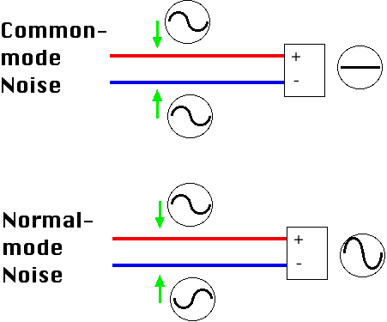
By No machine-readable author provided. NekoJaNekoJa~commonswiki assumed (based on copyright claims). [GFDL (http://www.gnu.org/copyleft/fdl.html), CC-BY-SA-3.0 (http://creativecommons.org/licenses/by-sa/3.0/) or CC BY-SA 2.5-2.0-1.0 (http://creativecommons.org/licenses/by-sa/2.5-2.0-1.0)], via Wikimedia Commons
EQUIPMENT:

A Spectrum Analyzer was used when testing radiated emissions.

Here are images of the machine in the EMI chamber:
Radiated emissions test:
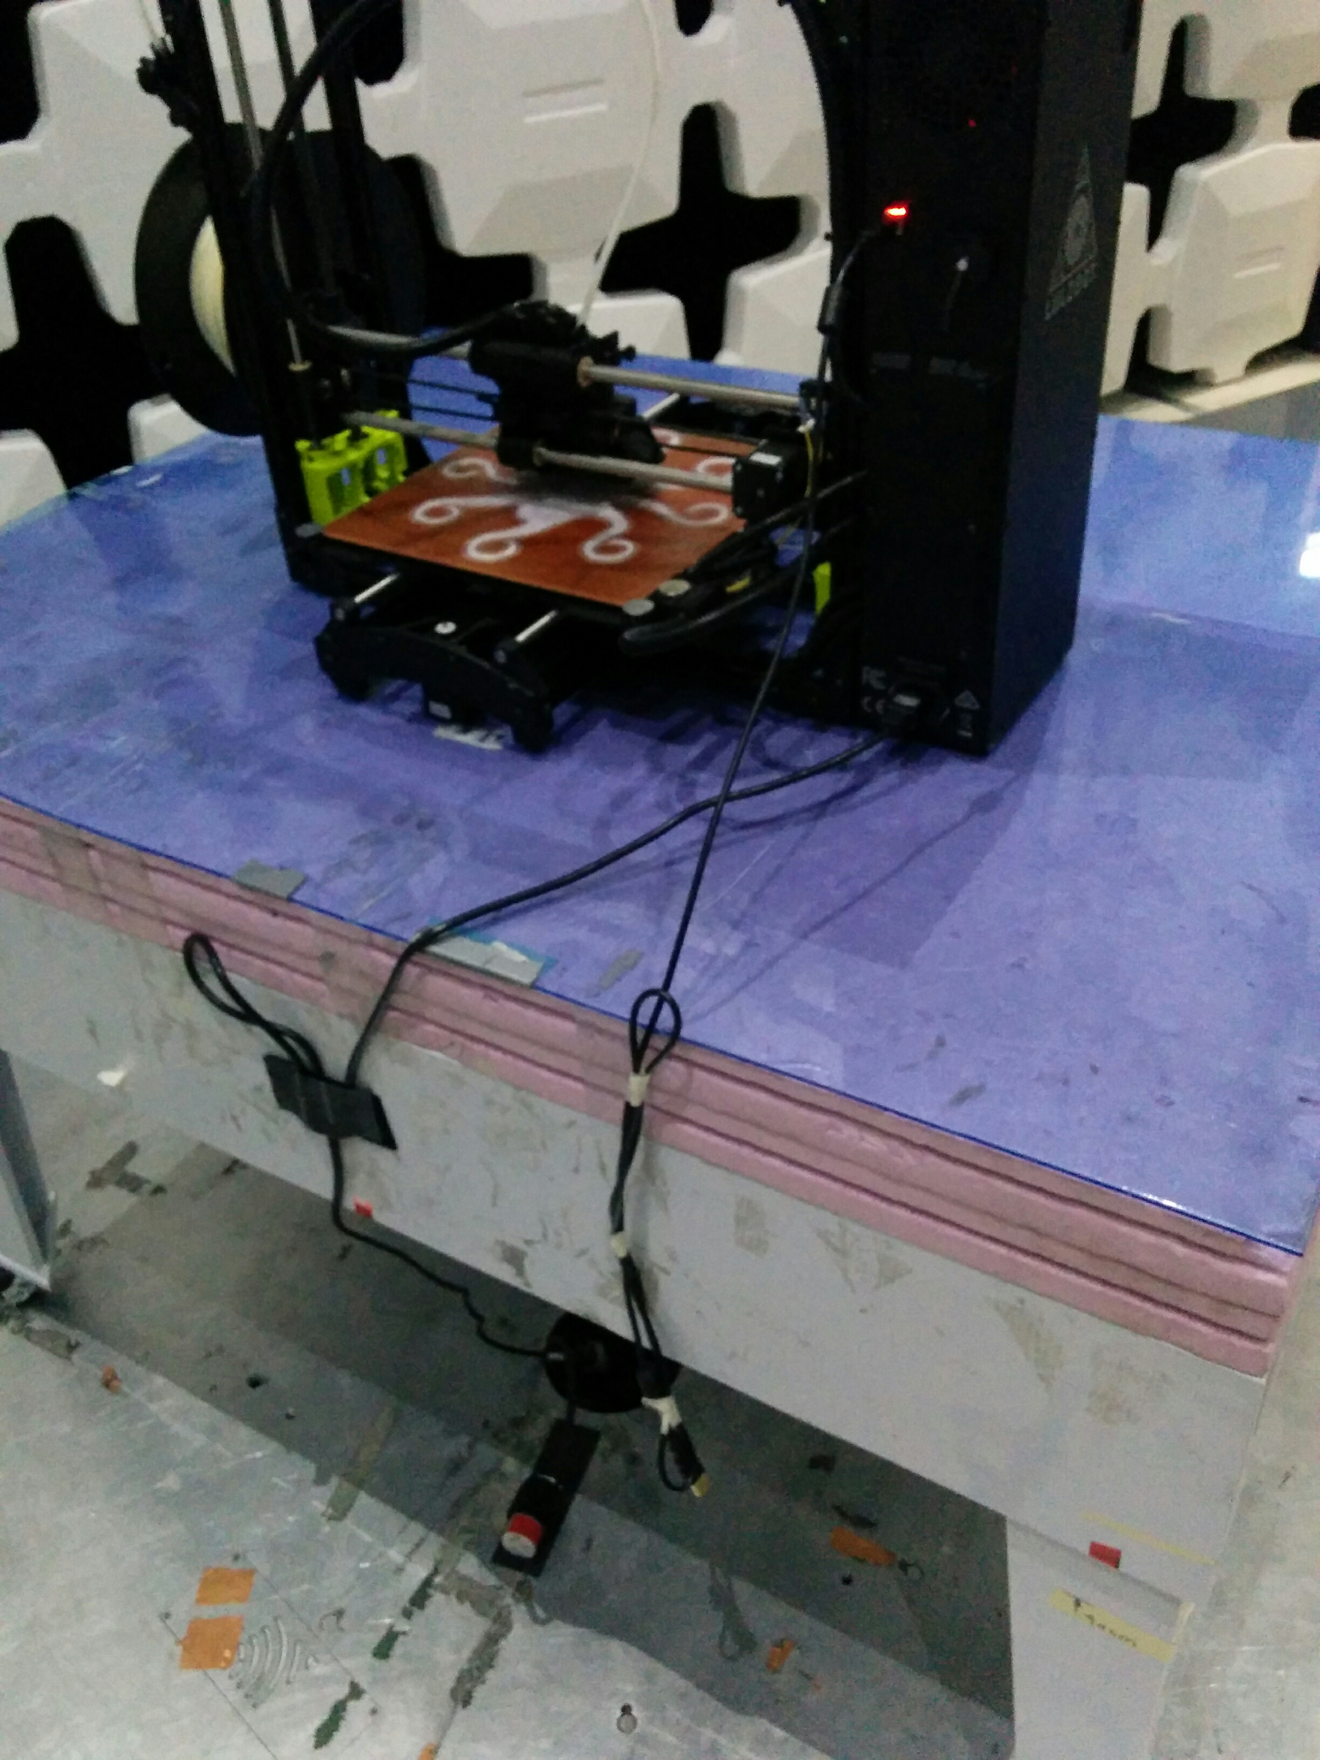

Conducted Emissions test:
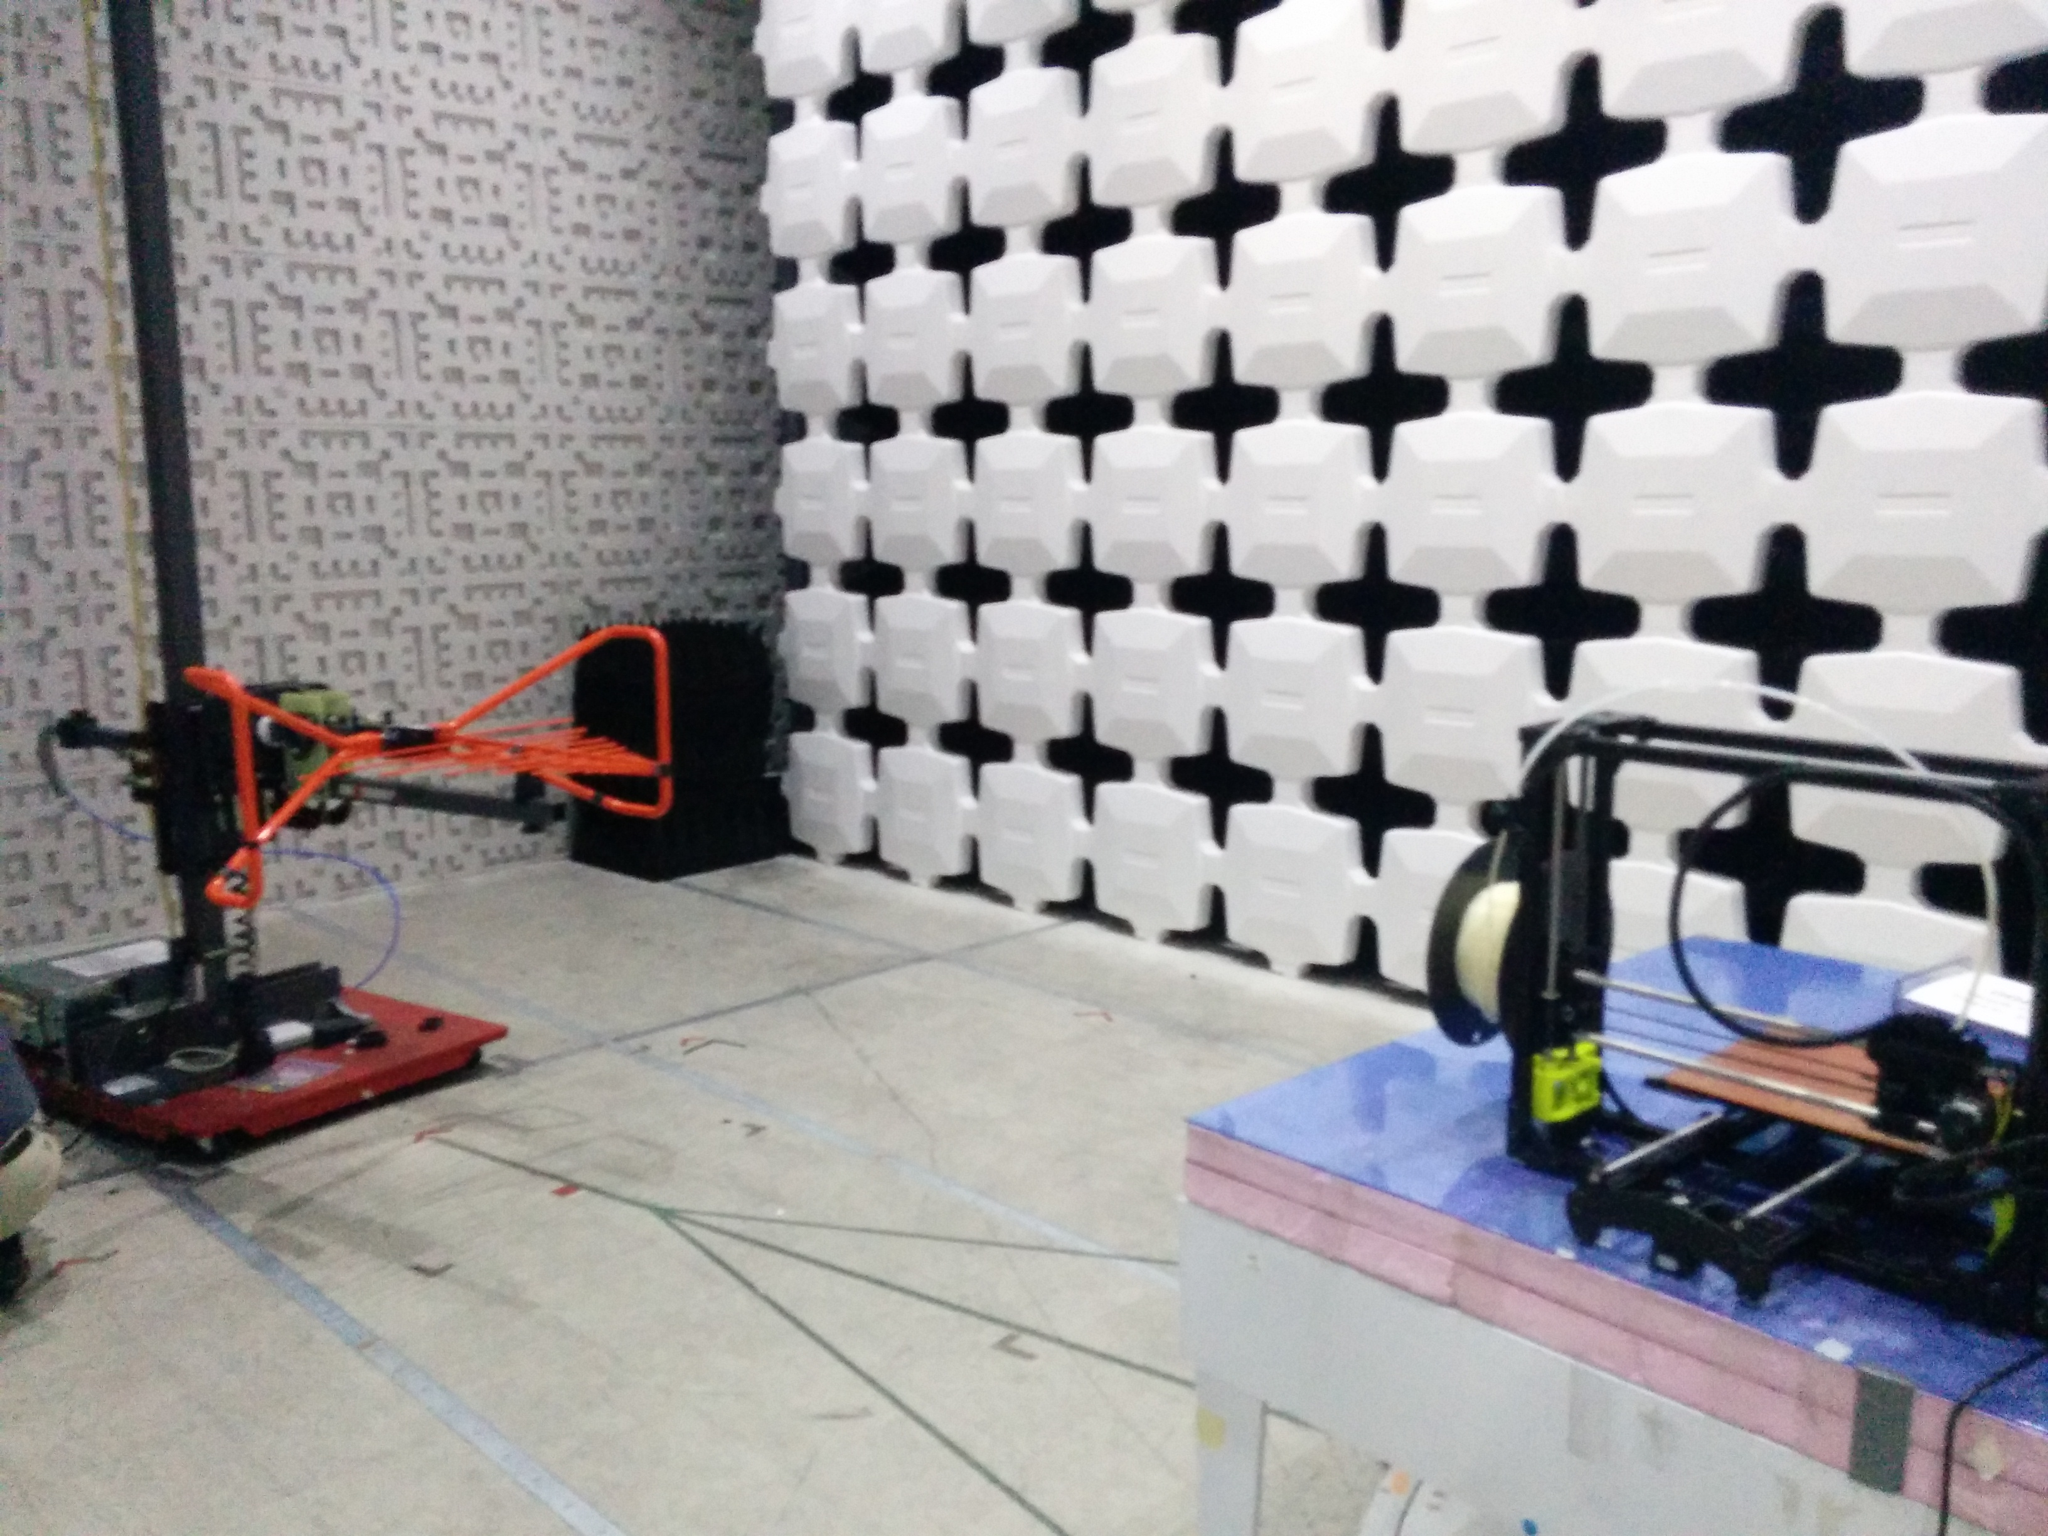

PROCEDURE:

EMI Testing Procedure:
Place the machine on the turning table in the EMI chamber. Run through the spectrum (30MHz – 1GHz) with the antenna in its horizontal and vertical positions. If any frequency is above the specified limit then examine those frequencies individually and move and/or unplug wires to find the source.

TEST DATA and COMPLETE RESULTS:

The following data was gathered on 01/15/2016 when Nutmeg 01 passed the Class B requirements:
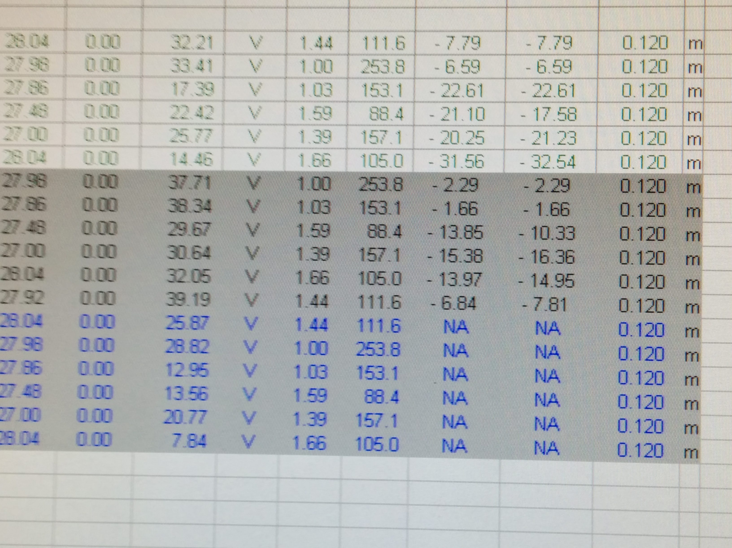

EMC Test Data:

Here is the six quasi-peek points gathered from the radiated emissions test:

Any positive value that is found above the limit is consider not passing.

Conducted emissions test results:

Line:

Neutral:
OTHER INFO:

Class B is required to market the machine as a consumer product as well as selling it some large retail stores.

